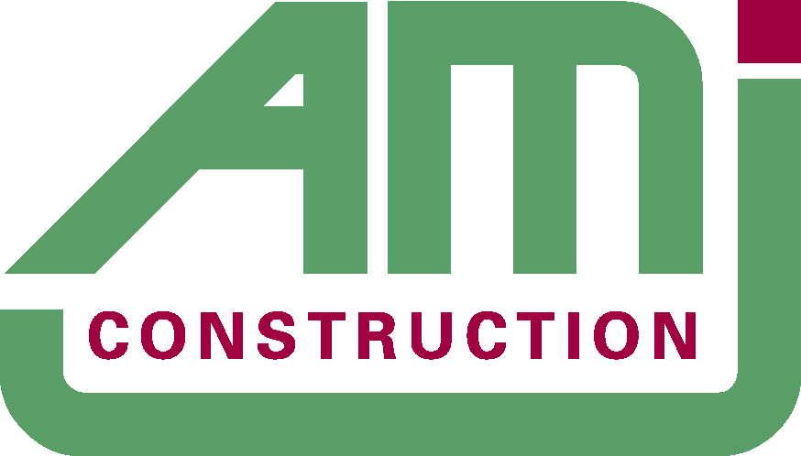

AMJ Construction Ltd ensures that this statement and the associated procedures apply to all activities and work undertaken within the company.

AMJ Construction Ltd can demonstrate its ability to consistently meet customer, statutory and regulatory requirements together with its commitment to enhance customer satisfaction in accordance with our clients’ needs and continual improvement of our systems.

AMJ’s success is based on their expertise and commitment of its experienced and professional, management and construction personnel. Not only are we committed to delivering a quality end product but also in providing our clients with a superior service throughout the construction process.

AMJ’s approach is to listen and discuss in detail the individual needs of every contract so our clients receive what they require and more importantly, know exactly what they are getting before any contract is signed. We work closely and collaboratively with our clients throughout project delivery to ensure their expectations are met.

AMJ’s philosophy is to maintain and where possible improve our record of providing work of the highest quality, in accordance with the clients’ requirements, on time and within budget. To this end we endeavour to work as a team in a spirit of co-operation with the client and their professional representatives.

AMJ is committed to:

- Setting and monitoring Targets and Objectives
- Working towards the requirements of BS EN ISO 9001: 2008
- Reducing incidents and customer complaints
4. Identifying improvements to existing working practices
5. Provide a top quality and professional project management service through the delivery of projects
6. Continually evaluate the effectiveness of Health and Safety plans and worksheets

For AMJ Construction Ltd to achieve the above objectives, all employees & sub-contractors must:

7. Understand the client’s requirements.
8. Be responsible and accountable for the quality of service and quality of work

The Directors of AMJ Construction Ltd are totally committed to this Statement (ie: that complies with the requirements of BS EN ISO 9001: 2008) and it is understood and implemented by all employees & sub-contractors.

This statement will be reviewed annually (or as and when required) by the Directors.

It is briefed and acknowledged by all employees on induction and following any policy changes. It is also available to suppliers, clients and the public on the BCM website
www.amjconstruction.co.uk.

